Image Testing:

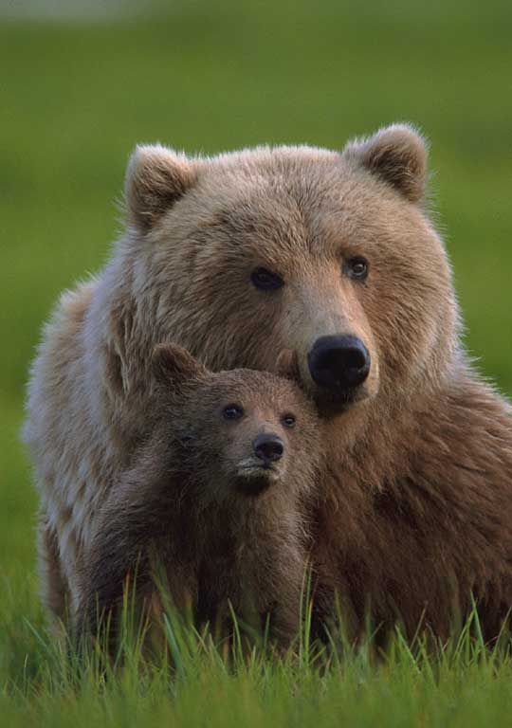

Command : python Final_Prediction.py 1043.jpg

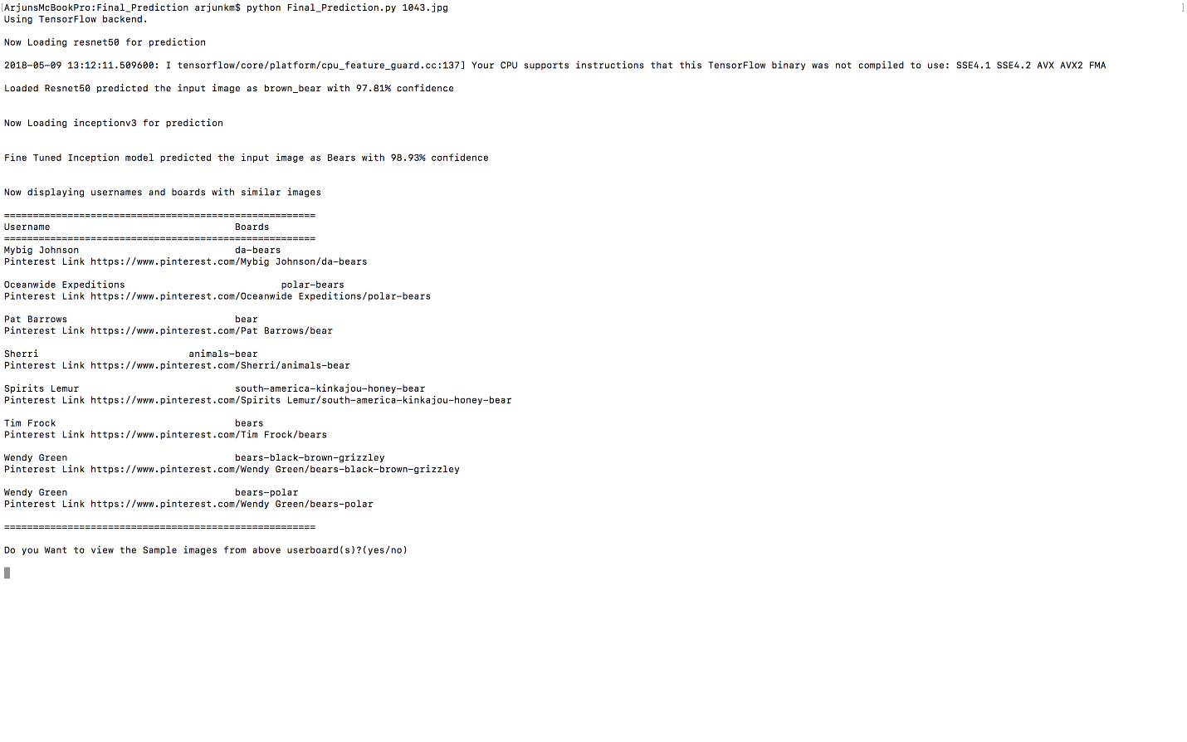

After entering yes:

Sample images from User/board displayed above is shown.

